Department of Computer Technology

Vision of the Department
To be a preferred hub for nurturing computer engineering aspirants through innovative, ethical, value-based technical education, impactful research, and industry collaboration, to become successful professionals contributing for the betterment of society.

Mission of the Department
To nurture computer engineering professionals by offering: Dynamic learning environment that encourages problem-solving using emerging technology, · National Education Policy aligned evidence-based technical education, fostering innovation, research, and industry–institute
collaboration, Holistic, ethical and sustainable development for lifelong success.

Session 2026-2027(ODD)

Vision: Dream of where you want. | Mission: Means to achieve Vision

Program Educational Objectives of the program (PEO): (broad statements that describe the professional and career accomplishments)
PEO1 | Preparation | P: Preparation | Pep-CL abbreviation
PEO2 | Core Competence | E: Environment (Learning Environment) | pronounce as Pep-si-lL easy to recall
PEO3 | Breadth | P: Professionalism
PEO4 | Professionalism | C: Core Competence
PEO5 | Learning  Environment | L: Breadth (Learning in diverse areas)

Program Outcomes (PO): (statements that describe what a student should be able to do and know by the end of a program)

Keywords of POs:
Engineering knowledge, Problem analysis, Design/development of solutions, Conduct Investigations of Complex Problems, Engineering Tool Usage, The Engineer and The World, Ethics, Individual and Collaborative Team work, Communication, Project Management and Finance, Life-Long Learning

PSO Keywords: Cutting edge technologies, Research

“I am an engineer, and I know how to apply engineering knowledge to investigate, analyse and design solutions to complex problems using tools for entire world following all ethics in a collaborative way with proper management skills throughout my life.” to contribute to the development of cutting-edge technologies and Research.

Integrity: I will adhere to the Laboratory Code of Conduct and ethics in its entirety.

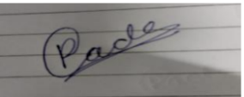
Poonam Gade / 9-08-2026

Name and Signature of Student and Date
(Signature and Date in Handwritten)

Department of Computer Technology

Vision of the Department
To be a preferred hub for nurturing computer engineering aspirants through innovative, ethical, value-based technical education, impactful research, and industry collaboration, to become successful professionals contributing for the betterment of society.

Mission of the Department
To nurture computer engineering professionals by offering: Dynamic learning environment that encourages problem-solving using emerging technology, · National Education Policy aligned evidence-based technical education, fostering innovation, research, and industry–institute
collaboration, Holistic, ethical and sustainable development for lifelong success.

Session | 2026-27 (ODD) | Course Name | LAB: Software Engineering
Semester | 7th | Course Code | 23CT1704
Roll No | 12 | Name of Student | Poonam Gade

Practical Number | 3
Course Outcome | CO1 Understand software engineering process models, incorporating requirement  engineering principles and software design fundamentals for a given project.  CO2 Apply testing principles by selecting and using appropriate testing strategies to  effectively evaluate a specific application  CO3 Use fundamental concepts of software configuration management, version  control, and change management in software development.  CO4 Analyze the cost estimation techniques and the severity of software risk for a  given application.  CO5 Evaluate the effectiveness of basic operations in Subversion (SVN) for  maintaining efficient software version control.
Aim | To study and draw the Data Flow Diagrams (DFDs) at Level 0 (Context Diagram) and Level 1 for the College Management System using StarUML. Online Voting System.
Problem Definition | An Online Voting System is a software application that allows eligible voters to register, log in securely, view candidate information, cast their vote electronically, and receive voting confirmation. The Election Administrator manages voter and candidate information and monitors the election process. The system securely stores votes and generates the final election results.  The DFD represents how information flows between voters, administrators, system processes, and databases.
Theory  (100 words) | What is a Data Flow Diagram?  A Data Flow Diagram (DFD) is a graphical representation of how data moves through a system. It shows:  - External Entities – people or systems interacting with the system.  - Processes – operations performed by the system.  - Data Stores – databases or files used to store information.  - Data Flows – movement of information between entities, processes and data stores.  DFDs are useful during the System Analysis and Design phase because they help understand and document system requirements. This follows the definition and components given in your practical material.  Level 0 DFD  The complete Online Voting System is shown as one process.  External Entities:  - Voter  - Election Administrator  Main Process:  - 0.0 Online Voting System  Main Data Flows:  - Voter → Registration/Login Details  - Voter → Vote  - System → Candidate List  - System → Vote Confirmation  - Administrator → Candidate/Election Details  - System → Election Results  Level 1 DFD  The Online Voting System is divided into four main processes:  - Voter Registration & Login  - Manage Candidates  - Cast Vote  1.4 Count Votes & Generate Results  Data Stores:  - D1 – Voter Database  - D2 – Candidate Database  - D3 – Vote Database  - D4 – Election/Result Database  Main Data Flow  Voter → Registration/Login → Voter Database  Administrator → Candidate Details → Manage Candidates → Candidate Database  Voter → Selected Candidate → Cast Vote → Vote Database  Vote Database → Count Votes & Generate Results → Election/Result Database  Election/Result Database → Election Results → Voter/Administrator
Procedure and Execution  (100 Words) | Algorithm(Steps):  Step 1: Start  Step 2: Identify the external entities.  Step 3: Identify the main Online Voting System process.  Step 4: Draw Level 0 DFD with:  Voter  Election Administrator  Online Voting System  Step 5: Identify the major internal processes.  Step 6: Create Level 1 processes:  1.1 Voter Registration & Login  1.2 Manage Candidates  1.3 Cast Vote  1.4 Count Votes & Generate Results  Step 7: Identify required data stores.  Step 8: Create:  D1 Voter Database  D2 Candidate Database  D3 Vote Database  D4 Election/Result Database  Step 9: Connect entities, processes and data stores.  Step 10: Label all data flows.  Step 11: Verify the DFD.  Step 12: Save the diagram.  Step 13: Stop
Output:
1)Level 0 DFD (Context Diagram)
The Level 0 Context Diagram of the Online Voting System was successfully created. It represents the complete system as a single process and shows interaction between the Voter, Election Administrator, and the Online Voting System.
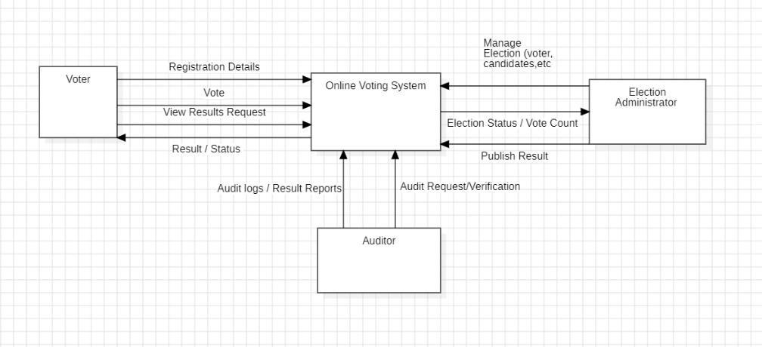
2)Level 1 DFD
The Level 1 DFD was successfully created. It divides the system into four major processes:
- Voter Registration & Login
- Manage Candidates
- Cast Vote
- Count Votes & Generate Results
It also represents the required databases and data flows.
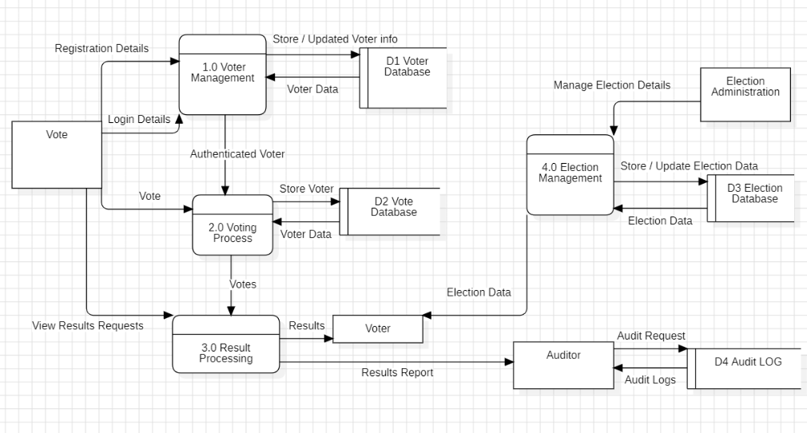

Output Analysis | The Level 0 DFD provides a high-level view of the Online Voting System and identifies the main external entities interacting with the system.  The Level 1 DFD provides more detailed information about the internal operations of the system. It shows how voter information, candidate information and votes are processed and stored. It also shows how the final election results are generated.
Conclusion | The Data Flow Diagrams for the Online Voting System were successfully studied and designed using StarUML. The Level 0 DFD represents the complete system as a single process, while the Level 1 DFD divides the system into major functions such as voter registration and login, candidate management, vote casting, and result generation. The DFD provides a clear understanding of how data flows between users, system processes and databases.
Link of student Github profile where lab assignment has been upload | https://github.com/23070177-cmyk
Plag Report (Similarity index < 12%) | 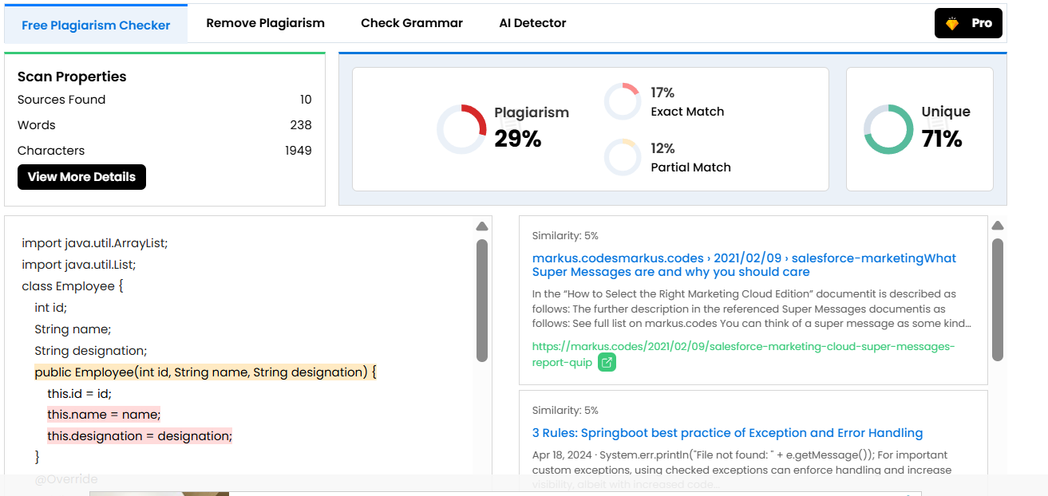
Date | 9-08-2026

